**Title**

Mix design and Strength Prediction of Concrete using Machine Learning Techniques

**Problem Statement**

The proportioning of Concrete mix design is a major problem to achieve the required strength. Generally, traditional concrete mix design proportions are based on trial and error mix formulation or based on previous experience. It is an important and primary requirement to optimize the concrete compositions by selecting the exact amount of mix design parameters. Recently, Machine Learning techniques are being applied to deal with this problem. Its classifiers such as Random Forest classifier, Native Baye’s Algorithm, K-nearest neighbor (k-nn) classifiers, Artificial Neutral Network etc are being used to classify, optimize and predict the compressive strength. But it requires very large dataset. Therefore, an advanced Machine Learning techniques based on classifiers method need to develop that requires less data to classify, optimize and predict the compressive strength.

**Background**

Concrete mix design still remains an active research area in concrete technology in recent years. Some mix design approaches have been proposed over these years. C. Deepa et al. (2010) predict the compressive strength of high performance concrete by using the classification algorithm like Multilayer Perception, M5P Tree Models and Linear Regression. Recently random forest classifier, native baye’s algorithm, K-nearest neighbor (k-nn) classifier is used to predict the strength of geo-polymer concrete.

**Methodology**

Procedure of the strength prediction is shown in figure 1**.**

*Step 1: Data collection and dataset preparation*

This will involve the preparation of different concrete mix design using particle packing density method and collecting the data of strength by performing the destructive testing.

*Step 2: Developing a model*

Popular pertained machine learning classifiers models such as Random Forest classifier, Native Baye’s Algorithm, K-nearest neighbor (k-nn) classifiers and Artificial Neural Network (as shown in figure-2) will be exploited for this problem.

*Step 3: Training and experimentation on datasets*

The mix design model will be trained both on the large scale datasets as part of this project.

*Step 4: Deployment and analysis on real life scenario*

The trained and tested concrete mix design model will be deployed in a real-life scenario for further analysis where both positive and failure cases will be leveraged for further improvement in the methodology.

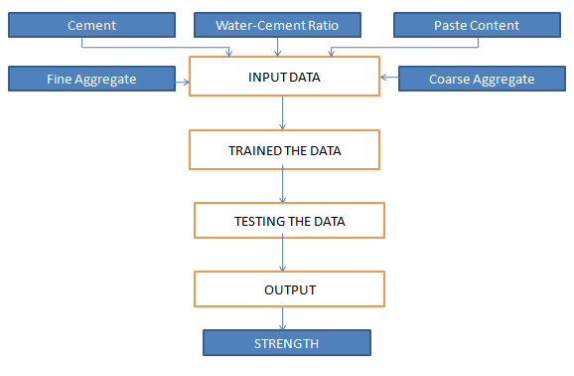

Figure 1. Procedure of Strength Prediction

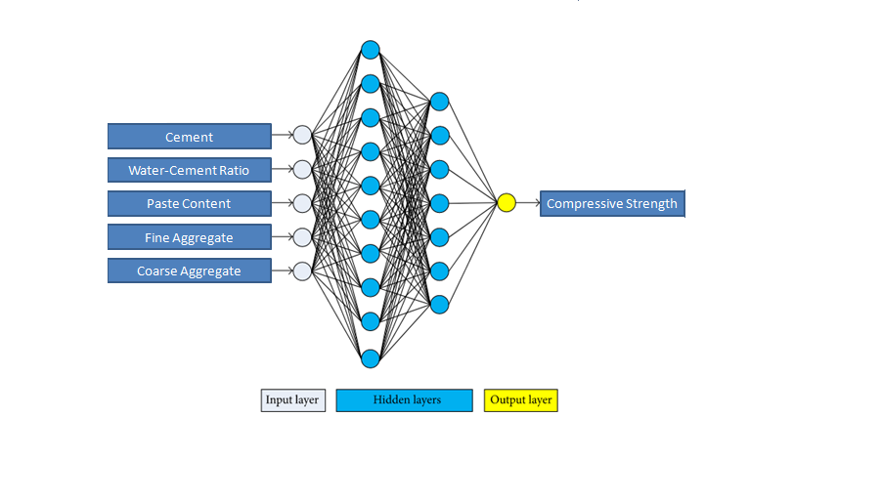

Figure 2. Architecture of Artificial Neural Network (Panagogiotis G. Asteris et al.)

**Experimental Design**

*Dataset*

Mix design compositions datasets such as correlation based features, ANOVA for data analysis will be use for experimentation and evaluation.

*Evaluation Measures*

Measures such as accuracy and Mean Average Precision (MAP) will be computed by comparing the mix design parameters with machine learning classifiers and real data from the experimental work.